To plot Even and Odd parts of a continuous time signal

CONTINUOUS of x(t)=e^(2t)

>> t=(-5:0.2:5);

x=exp(2*t);plot(t,x);

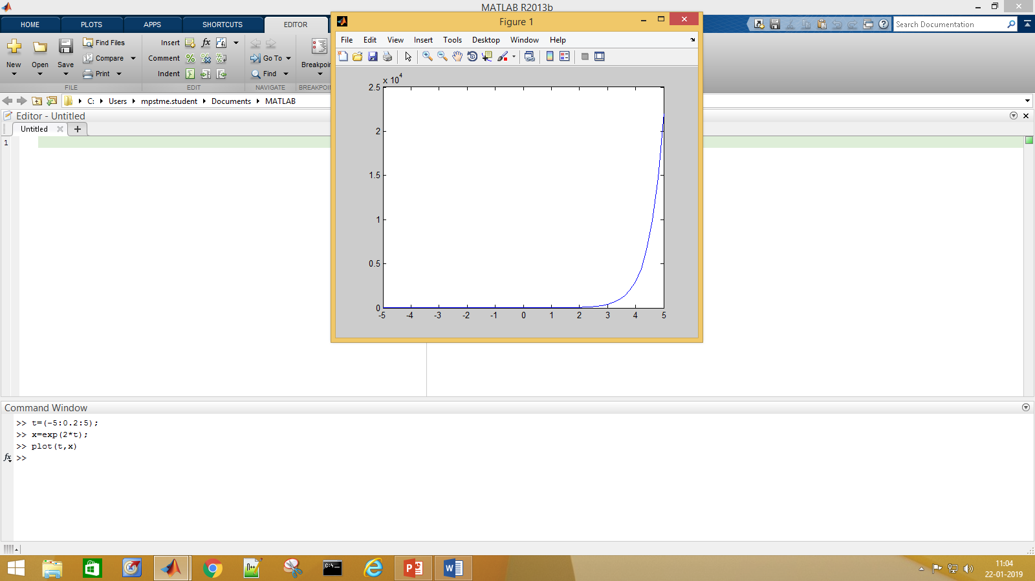

x1=exp(2*-t);

>> plot(t,x1)

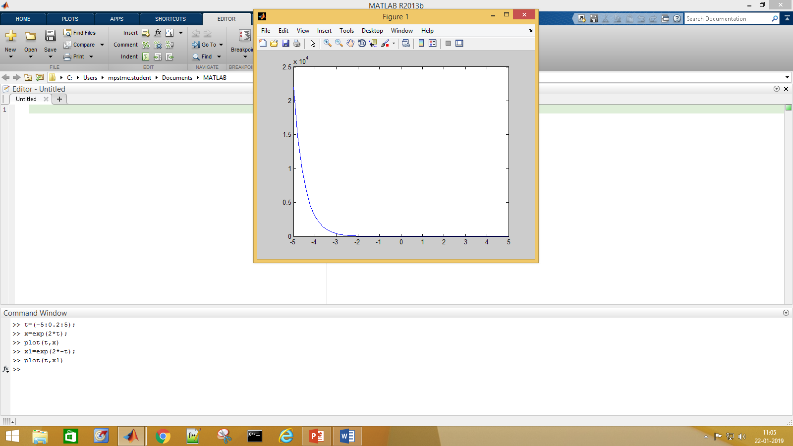

>> t=(-5:0.2:5);

>> x=exp(2*t);

>> plot(t,x)

>> x1=exp(2*-t);

>> plot(t,x1)

>> z=(x+x1)/2;

>> plot(t,z)

>>

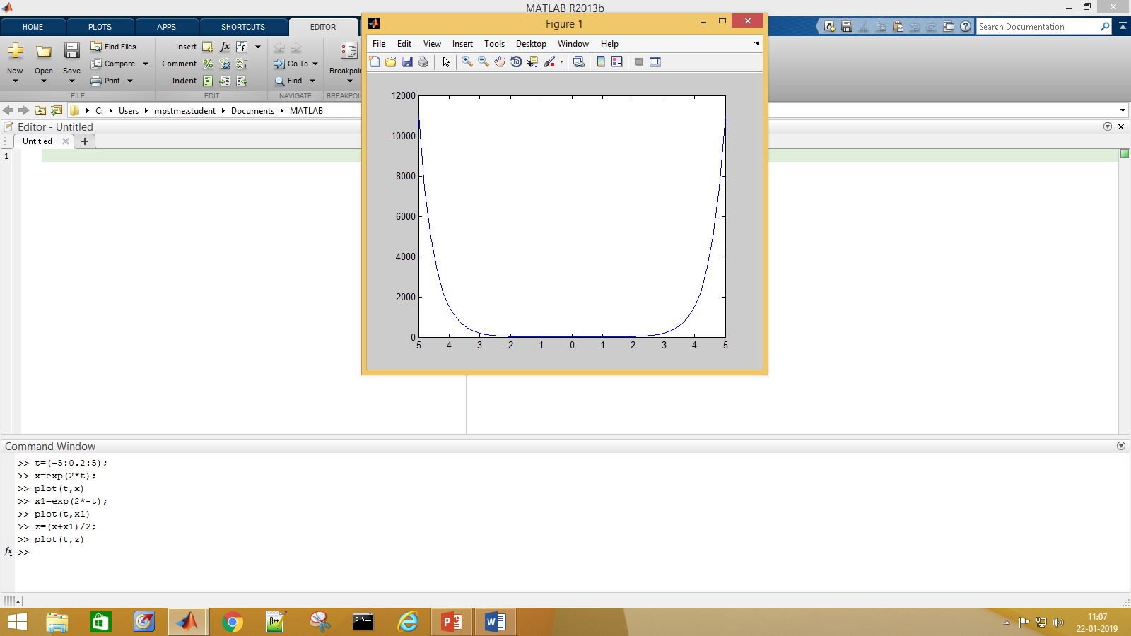

>> t=(-5:0.2:5);

>> x=exp(2*t);

>> plot(t,x)

>> x1=exp(2*-t);

>> plot(t,x1)

>> z=(x+x1)/2;

>> plot(t,z)

>> z1=(x-x1)/2;

>> plot(t,z1)

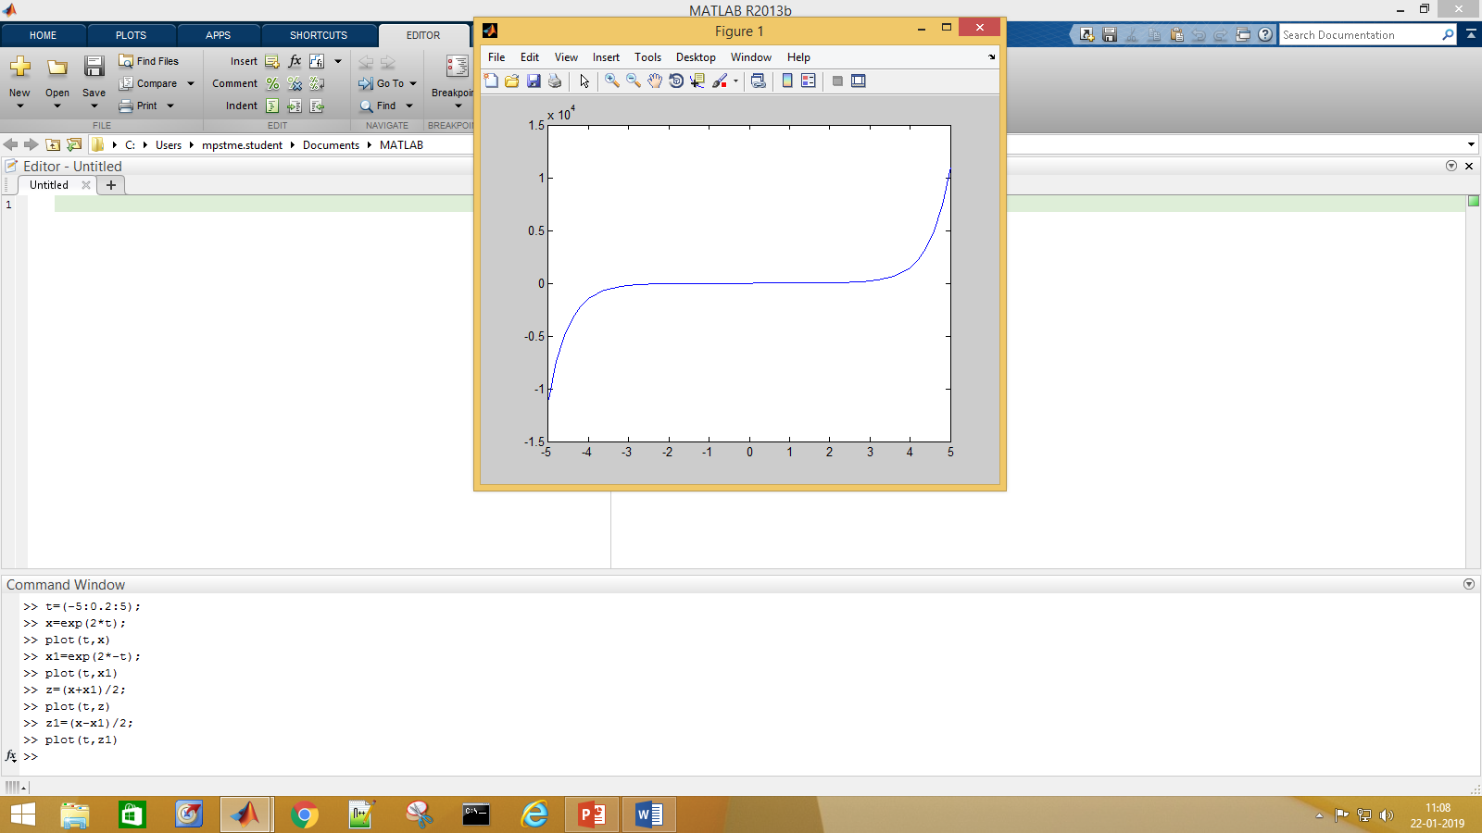

>> t=(-5:0.2:5);

>> x=exp(2*t);

>> plot(t,x)

>> x1=exp(2*-t);

>> plot(t,x1)

>> z=(x+x1)/2;

>> plot(t,z)

>> z1=(x-x1)/2;

>> plot(t,z1)

>> subplot(x,x1,z,z1)

Operands to the || and && operators must be convertible to logical scalar values.

Error in subplot (line 217)

if ~ishghandle(h, 'axes') || ...

>> subplot(2,2,1);

>> plot(t,x);

>> title('signal x(t)')

>> subplot(2,2,2);

>> plot(t,x1);

>> title('signal x(-t)')

>> subplot(2,2,3);

>> plot(t,z);

>> title('even')

>> subplot(2,2,4);

>> plot(t,z1);

>> title('odd')

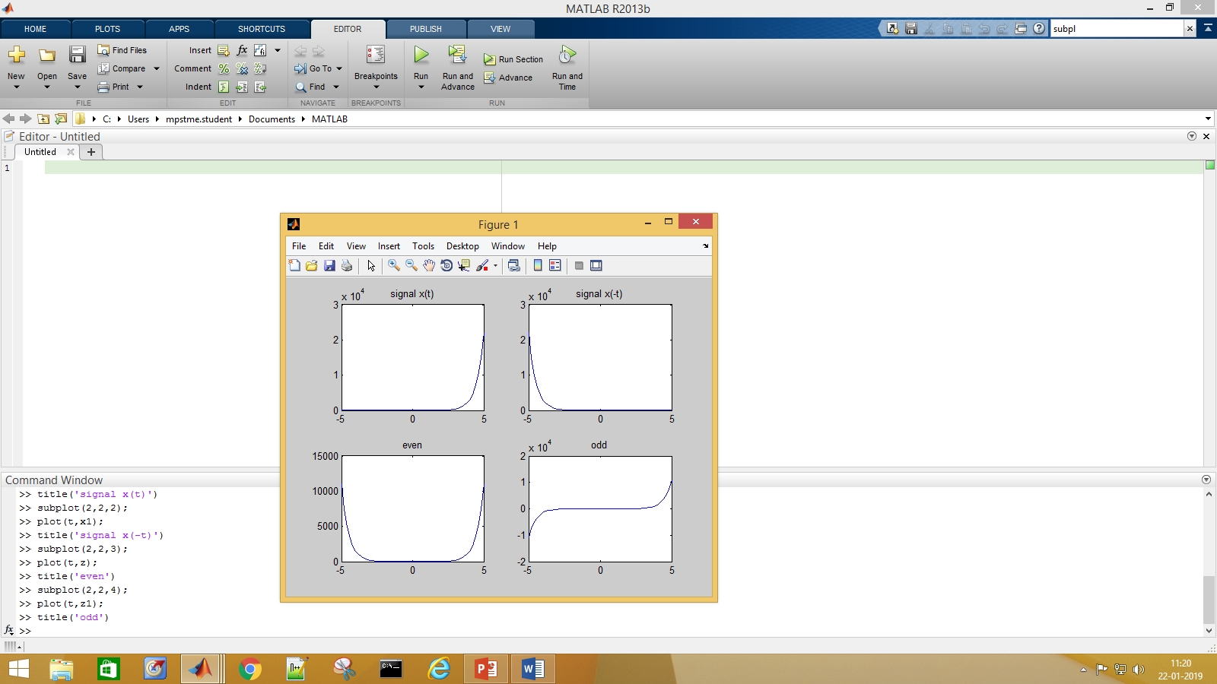

**>> if(x==x1)**

**disp('even')**

**else if(x1==-x)**

**disp('odd')**

**else**

**disp('neither even nor odd')**

**end**

**end**

**neither even nor odd**

t=(-5:0.2:5);

x=exp(2*t);

plot(t,x)

x1=exp(2*-t);

plot(t,x1)

z=(x+x1)/2;

plot(t,z)

z1=(x-x1)/2;

plot(t,z1)

subplot(2,2,1);

plot(t,x);

title('signal x(t)')

subplot(2,2,2);

plot(t,x1);

title('signal x(-t)')

subplot(2,2,3);

plot(t,z);

title('even')

subplot(2,2,4);

plot(t,z1);

title('odd')

if(x==x1)

disp('even')

else if(x1==-x)

disp('odd')

else

disp('neither even nor odd')

end

end